Name _____________________________________________________________________________
-ap word family
Directions: Choose a map. Color it appropriately. Write the word for the picture that is on the map. All words will end with -ap.

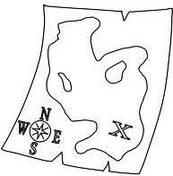
- __________________________ 4. ___________________________

- __________________________ 5. ___________________________

- __________________________ 6. ___________________________

Choose 1 –ap word and write a sentence.
__________________________________________________________________________________
__________________________________________________________________________________

